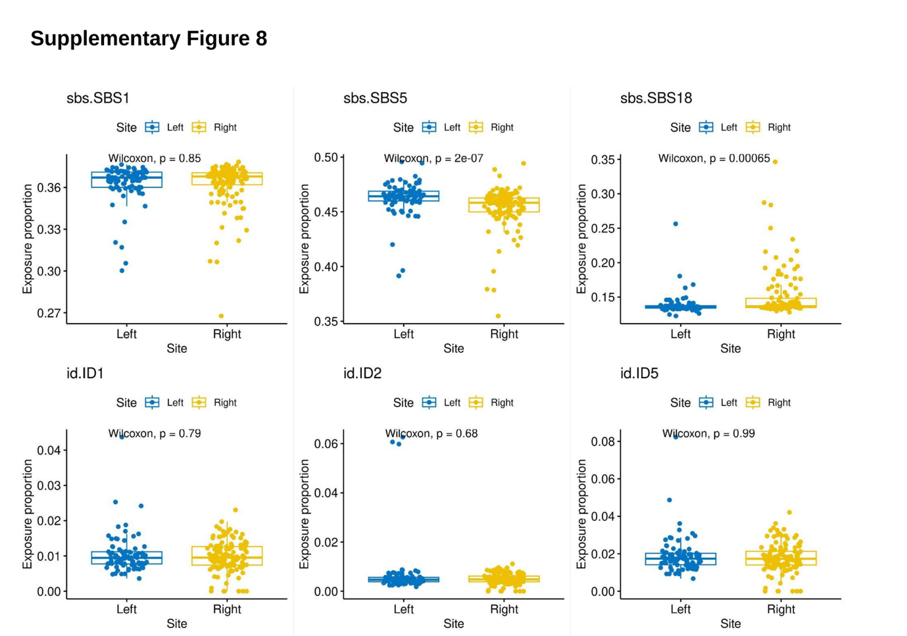Supplementary Figure 8. Site-specific differences in mutational signatures in the healthy colon.
For mutational signatures observed ubiquitously in the healthy colon, we show the proportion of signature exposures, calculated by Lee-Six et al [5] for healthy colonic crypts labelled as Left colon (corresponding to distal) or Right colon (corresponding to proximal). Significant site-specific differences exist for SBS5 and SBS18, although the magnitude of the effect is relatively minor and so is unlikely to largely contribute to site-specificity of APC genotypes in CRCs.

